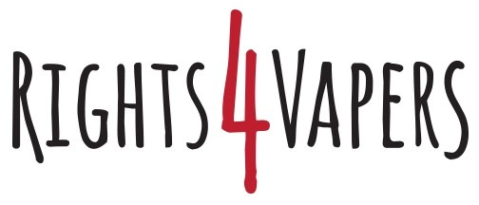

Submission to the Third Legislative Review of the Tobacco and Vaping Products Act

Maria Papaioannoy
Rights4Vapers
maria@rights4vapers.com
September 12, 2025

Introduction
Rights4Vapers began life as a movement to give Canadians who vape a voice, educate them on the harm reduction potential of vapour products and empower them to take action.
Over the years, we have evolved to become a movement that calls for the accessibility, availability and affordability of all safer nicotine products. Our goal is to ensure that Canadians who smoke have a wide range of options available to them to help them quit smoking. It could be vapour pouches, nicotine pouches, patches, gum or cold turkey.
Reducing deadly cigarette consumption is the ultimate objective.
We have seen the emergence of innovative and accepted nicotine delivery systems. We have the opportunity with the review of the Tobacco and Vaping Products Act to rethink how we regulate these products.
The voice of the people who use safer nicotine products to improve their health should not be forgotten. These are the people who can tell the government how these products are used, what works, what doesn’t. They have made the choice to quit smoking and should be celebrated not forgotten. There is a community of millions in Canada who are looking to the federal government to lead on this issue. They are part of Health Canada’s mandate to improve public health. They have done what they can. It is now up to the federal government to live up to its side of the bargain.
The recommendations at the heart of our submission to this review is the creation of a separate Safer Nicotine Act that separates combustible tobacco products from the proven, less harmful nicotine products on the market today. Our guiding principle is that these products are not cigarettes and should not be regulated as such.

Part One: Changing Market
The central issue in Canada is not insufficient oversight but a flawed regulatory framework. Vaping and other safer nicotine products should be removed from the TVPA and placed under a single, modernized framework that consistently governs all reduced-risk alternatives. The current fragmented system, where products are divided across multiple regimes, creates confusion and undermines effective oversight.
Streamlining oversight under one coherent framework would be far more effective. In addition, the government should reconsider the impact of heavy taxation on vaping products. Excessive taxation has fuelled the growth of a black market, undermining public health goals and reducing compliance.
Compliance could be improved through common-sense regulation and by empowering provincial and municipal authorities to enforce existing rules, provided they receive proper training. Access to safer nicotine products should be normalized by making them available wherever cigarettes are sold, so that adult smokers have clear and convenient alternatives. Health warnings on cigarette packages should also include comparative risk information that highlights safer options, empowering consumers to make informed choices.

Part Two: Regulating in a Digital Era
The TVPA’s restrictions on promotion are largely copied from the Tobacco Act, which is inappropriate for safer nicotine products. Adults should be able to access truthful information about reduced-risk options, and individuals should be free to share their quit-smoking success stories on social media without fear of censorship. Allowing relative risk statements is long overdue, and normalizing the use of safer products among adults could help reduce their appeal to youth.
Instead of layering new enforcement tools onto outdated rules, the solution is to modernize the framework. Vaping products should be removed from the TVPA and brought under a single Act covering all safer nicotine products. This would reduce misinformation and make enforcement more practical in digital contexts.
If enforcement is to be applied online, it must be consistent. Vape shops and manufacturers are prohibited from sharing accurate, evidence-based information, while NGOs and health organizations—often funded with public money—are permitted to spread misinformation without consequence. This double standard is both dishonest and harmful. If accountability is to be meaningful, all actors must be held to the same standard.

Part Three: Facilitating Collaboration and Restoring Trust
Improving collaboration begins with genuine communication. Too often, federal, provincial, and municipal governments work in silos. Health Canada should actively coordinate with enforcement bodies at all levels, ensuring that inspection results, compliance data, and best practices are shared openly.

Transparency is essential. Despite federal regulation, the patchwork of provincial and municipal rules creates inconsistency and confusion. Local health organizations sometimes promote misleading information with no accountability or oversight.

Tweet from Durham Region Health Department in 2025
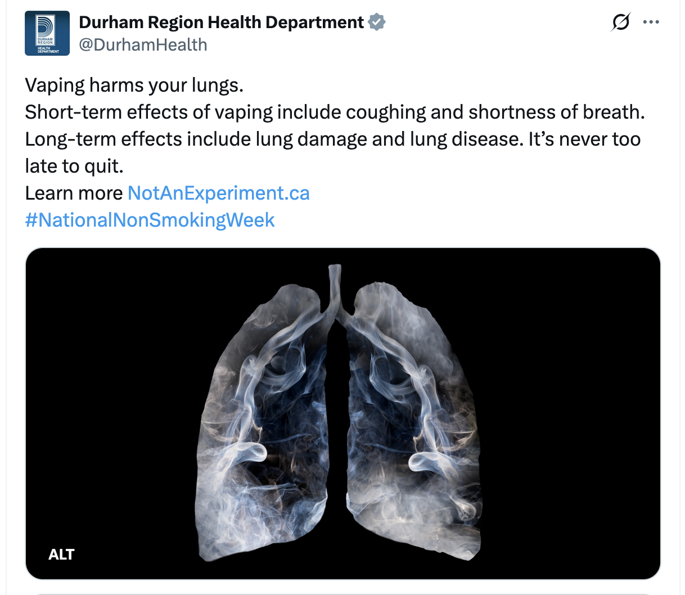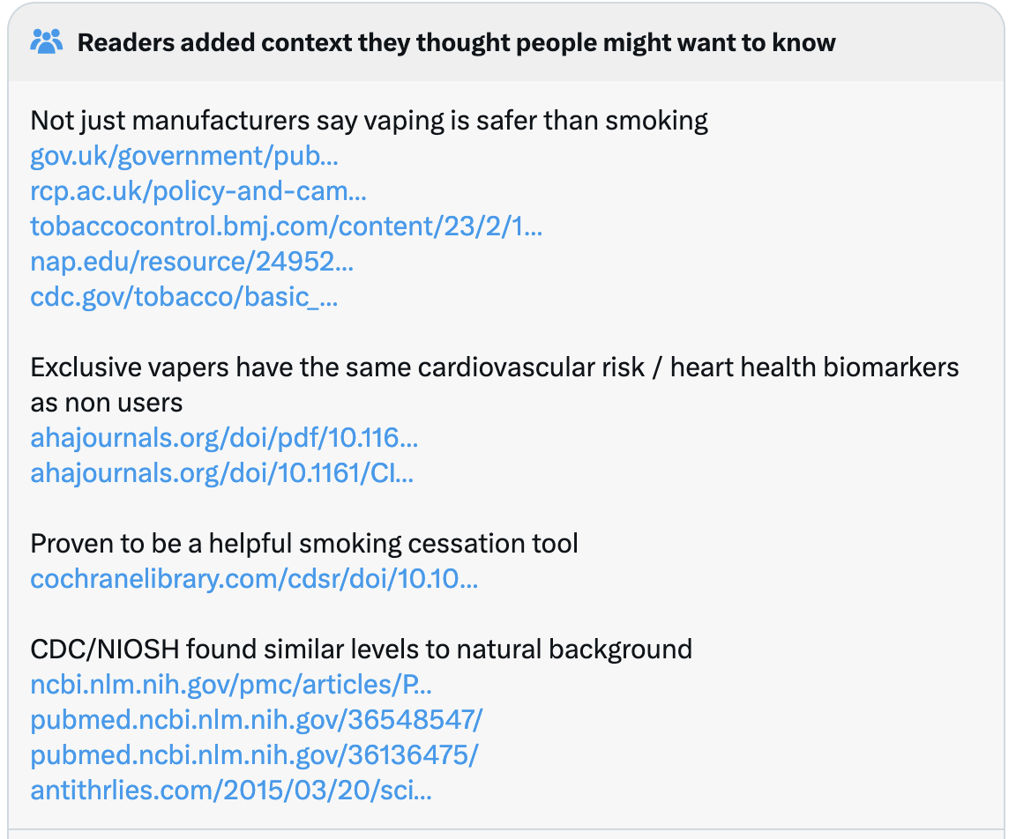

Campaigns such as Not An Experiment exaggerate risks and confuse the public. Transparent reporting of compliance and enforcement findings would help Canadians distinguish between evidence-based regulation and fear-driven messaging.
Compliance promotion should be rooted in truth. Youth vaping rates are declining, there are no deaths in Canada attributable to nicotine vaping, and the science is clear: vaping is significantly less harmful than smoking. Public education campaigns must reflect these facts so Canadians can make informed choices based on evidence rather than stigma.
Unfortunately, trust in public health has been undermined by both the COVID-19 response and the handling of vaping. Public Health Ontario’s own review of risk communication during the pandemic documented how mixed messages and shifting guidance eroded confidence in scientific expertise and reduced compliance. A similar pattern is evident in vaping.

A multi-country analysis that included Canada found that young people exposed to anti-vaping campaigns were actually more likely to believe vaping was as harmful or more harmful than smoking, evidence that fear-based campaigns increase misperceptions rather than correct them.
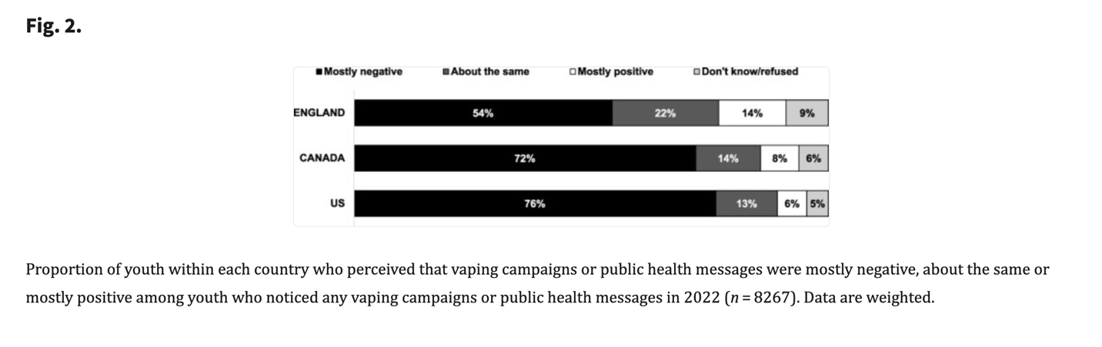
This problem was amplified during the 2019 EVALI outbreak in the United States, when Canadian media and health authorities echoed the narrative that nicotine vaping was to blame. Subsequent research confirmed that in Canada, the proportion of smokers and vapers who correctly perceived vaping as less harmful than smoking dropped sharply after EVALI, coinciding with heightened exposure to negative news. This conflation of illicit THC products with nicotine vaping deepened public confusion and mistrust, and it continues to shape public opinion today.
These misperceptions matter for cessation. ITC research shows that smokers who do not believe vaping is less harmful than smoking are far less likely to use vaping products when trying to quit—undermining one of the most effective harm-reduction tools available. Even Health Canada’s own commissioned research on youth and young adults (Vaping Segmentation Study, 2024) highlights widespread confusion about relative risks, showing that government messaging has failed to provide clarity. Meanwhile, publicly funded campaigns such as Consider the Consequences of Vaping and websites like Not An Experiment continue to present vaping as equally or more harmful than smoking, directly contradicting the evidence base, including findings from the UK’s Office for Health Improvement and the Cochrane Review (2025 update).
The result is a cycle of misinformation that not only erodes public trust but also prevents smokers from switching to safer alternatives. Just as poor communication during COVID-19 weakened compliance and credibility, the same approach to vaping is undermining harm-reduction policy. By exaggerating risks, suppressing relative risk information, and permitting fear-based messaging, public health units have deepened mistrust and discouraged innovation, while unintentionally driving consumers toward the black market. Restoring trust requires transparent, evidence-based communication that empowers Canadians to make informed decisions.

Part Four: Conclusion
Canada urgently needs a modern, science-based framework for safer nicotine products. Vaping should be removed from the TVPA and reclassified under a new Safer Nicotine Act that governs all reduced-risk products as consumer goods. This framework should also broaden the definition of nicotine replacement therapy (NRT) to include any product proven to help people quit smoking, whether patches, gums, or innovative tools like vaping.
The evidence supporting vaping as a cessation aid is robust. A landmark randomized controlled trial published in the New England Journal of Medicine (Hajek et al., 2019) found e-cigarettes to be significantly more effective than NRT when combined with behavioural support. The Cochrane Review (2025 update) reached the same conclusion, reporting high-certainty evidence that nicotine e-cigarettes outperform both NRT and non-nicotine vaping. More recent trials reinforce these findings: a 2024 study in JAMA Internal Medicine (Lin et al., 2024) showed e-cigarettes to be as effective as varenicline and more effective than nicotine gum under minimal support conditions, while a systematic review by Vyas et al. (2024) confirmed their role as an effective cessation tool for adults. Canadian data further supports this: a 2025 survey by the Public Health Agency of Canada found that nearly one in five smokers attempting to quit used vaping products, and those who did were more likely to succeed.
The current approach, forcing vaping into the TVPA, blocks innovation, restricts access to legal products, and drives consumers toward unregulated markets. It also prevents Canadians from sharing or receiving factual information about safer alternatives.
A Safer Nicotine Act would provide a clear, evidence-based regulatory home for all reduced-risk products, support innovation, ensure safety and quality standards, and give adult smokers greater access to effective alternatives. Most importantly, it would position Canada as a global leader in tobacco harm reduction, saving lives by making safer nicotine options widely available and responsibly regulated.

